TRAINING AND SUPPORTERS APPAREL

We would like to introduce you to a new line of Stealers Clothing, along with our new “Base Burglar” logo. The new logo was created in house, by our very own Ben Matthews and will only be used on training gear and/or supporter’s apparel.

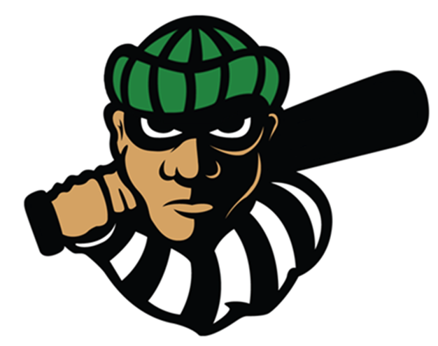

The “Robber” logo has been designed to depict the Stealers never say die attitude, to “steal” a win when one is not on offer, and to “steal” as many bases as possible.

All of the profits raised from the purchase of apparel depicted below, goes directly to the club and will continue to allow us to provide members with the best facilities in NSW.

Whether parent or player, we believe our new range of clothing showcasing the scripted “Stealers” or new “Base Burglar” logo will make a great addition to any wardrobe.

Please note, as the club does not want to outlay any unnecessary funds, there are minimum Manufacturer numbers required for us to be able to proceed with an order.

So, be one of the first in the club to own some of this apparel, and be proud to show your support for the No 1 baseball club in NSW.

Item | Image | Description | Sizes | Cost
Training Top | 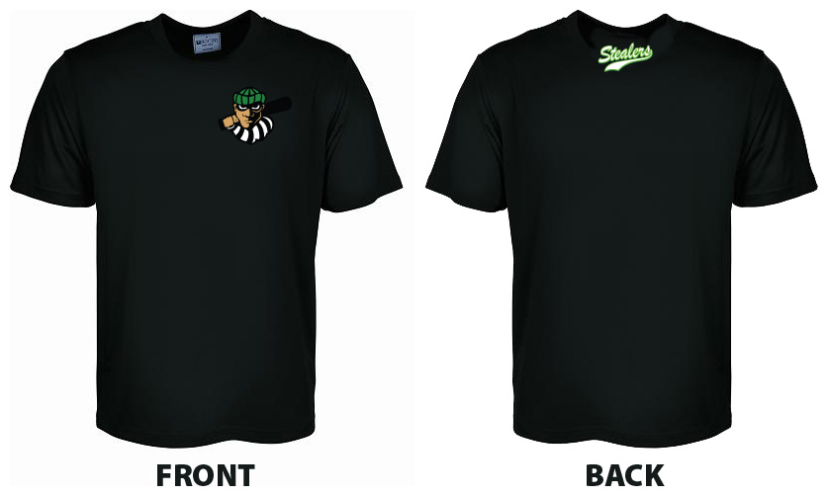 | - Classic t-shirt  - 160gsm  - Polyester micromesh | Kids  4 - 16  Adults  S – 3XL | $30
Training Shorts | 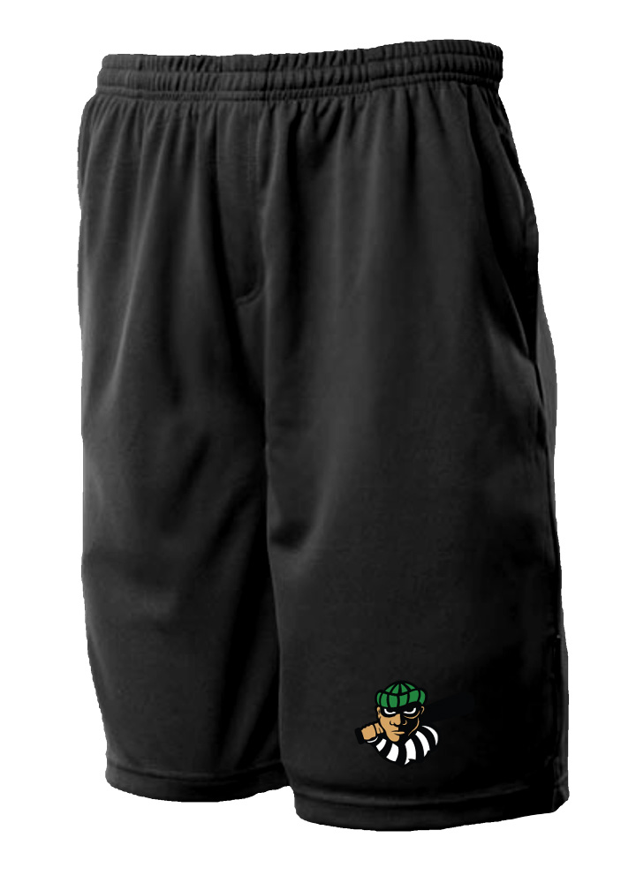 | - 160gm 100% Driwear polyester moisture removal.  - mini-waffle knit easy care fabric.  - elasticised draw string  - 2 x side pockets | Kids  6 - 16  Adult  S – 3XL | $25

Black Hoody | 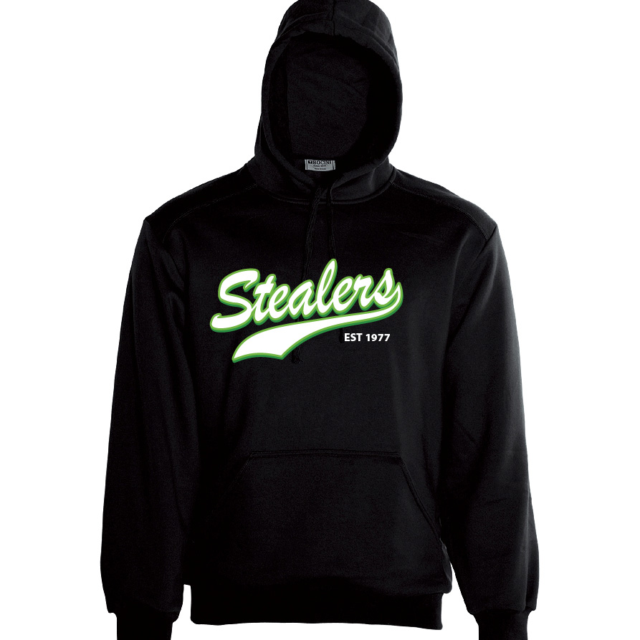 | - Pull Over Hoodie with Kangaroo Pocket.  - 320gsm Polyester / Cotton Fleece.  - Anti Pill Fabric.  - Cotton Jersey Lined Hood. | Kids  6-16  Adult  XS – 3XL | $45
Grey Hoody | 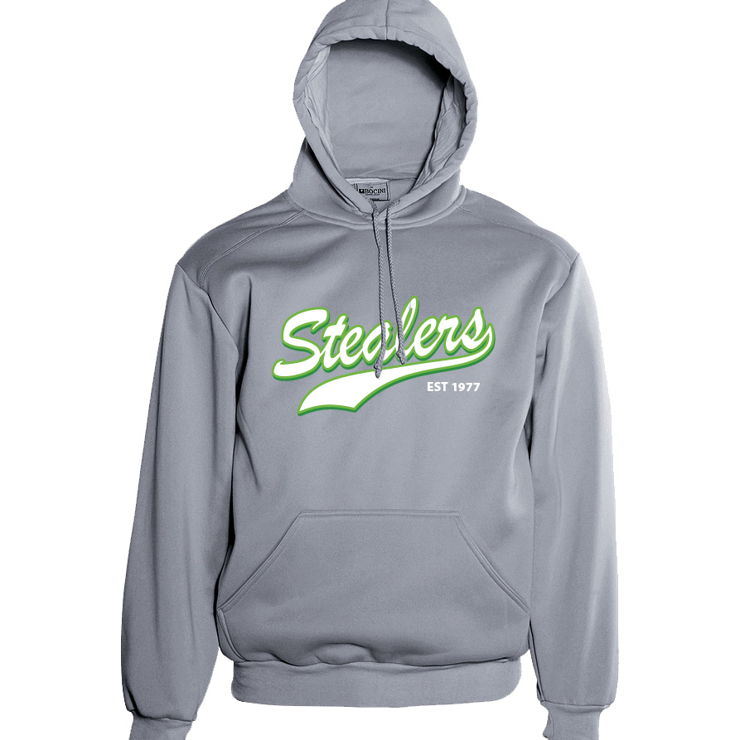 | - Pull Over Hoodie with kangaroo pocket.  - 320gsm Polyester / Cotton Fleece.  - Anti Pill Fabric.  - Cotton Jersey Lined Hood. | Child  6-16  Adults  XS – 3XL | $45

MAJESTIC Grey Hoody | 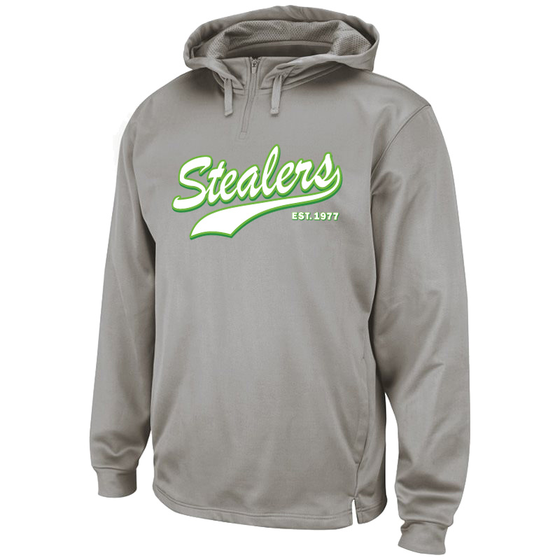 | - MAJESTIC brand  - Wear the same Therma Base® Hood that the MLB players wear on field.  - Built for performance and comfort, It features a 1/4 zipp at the neck and is constructed using our Therma Base® Polyester Endurance fabric for superior movement and style.  - An essential item for preseason, pregame or keeping warm for all elite athletes and teams. | Adults  S – 3XL | $60

Batting Tunnel Jacket  (Stealers logo) | 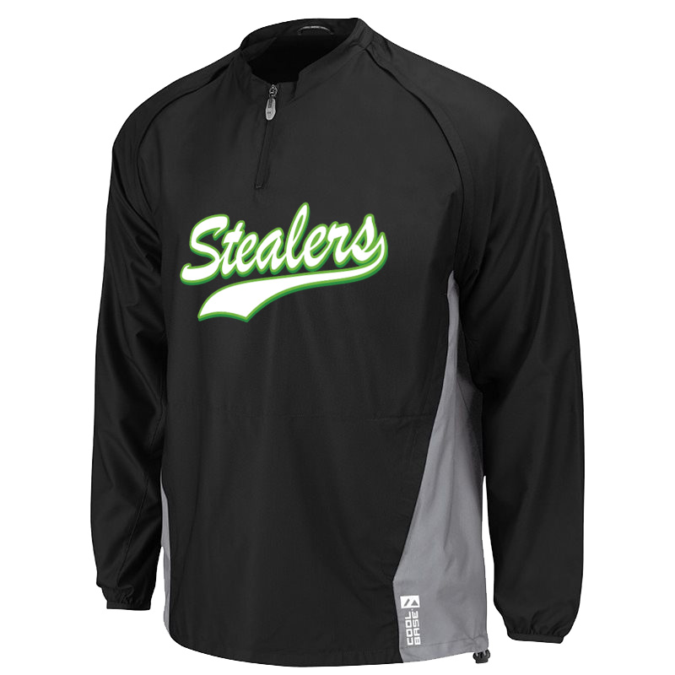 | - Majestic brand  - Cool Base® enhanced technology that keeps you cool and comfortable, as well as hidden chest vents to regulate temperature.  - It's water repellant and has back shoulder stretch panels that let you throw and swing without inhibiting your movement.  - Converts from long to short sleeve with one zip so you can wear when warm or cool. | Kids  S - XL  Adult  S – 3XL | $79
Batting Tunnel Jacket  (Base Burglar logo) | 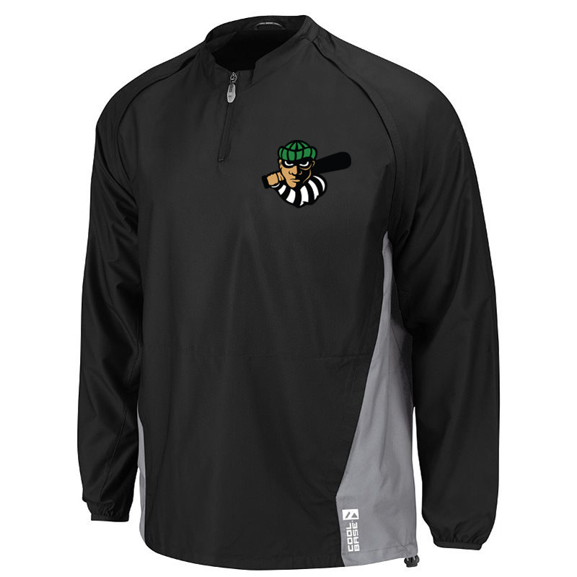 | - Majestic brand  - Cool Base® enhanced technology that keeps you cool and comfortable, as well as hidden chest vents to regulate temperature.  - It's water repellant and has back shoulder stretch panels that let you throw and swing without inhibiting your movement.  - Converts from long to short sleeve with one zip so you can wear when warm or cool. | Kids  S – XL  Adult  S – 3XL | $79

Club Polo Shirt | 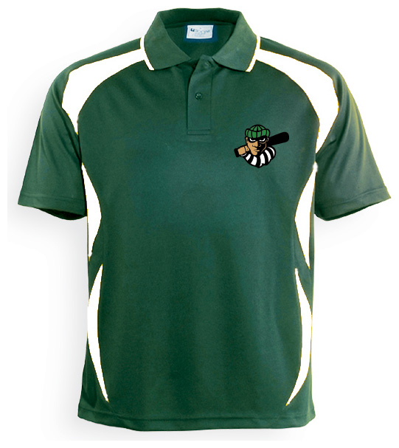 | - Breezeway sports polo with mesh contour panel.  - Moisture management.  - 160gsm.  - 100% breezeway polyester.  - Pique knit.  - Breathable.  - Quick dry. | Kids  6 - 16  Adult  S – 3XL | $40

KIDS SIZES
Please note the difference between the Batting Tunnel Jacket, and all other items. The kids batting tunnel jacket measurement is by height in inches, whilst all other items are FULL chest and in cm.

Training Shirt | 4 | 6 | 8 | 10 | 12 | 14 | 16
Full Chest (cm) | 70 | 75 | 80 | 85 | 90 | 95 | 100
Length (cm) | 50.5 | 3 | 55.5 | 58 | 60.5 | 63 | 65.5
Hoody | 4 | 6 | 8 | 10 | 12 | 14 | 16
Full Chest (cm) | N/A | 80 | 85 | 90 | 95 | 100 | 105
Length (cm) | N/A | 48.5 | 51.5 | 54.5 | 57.5 | 60.5 | 63.5
Polo | 4 | 6 | 8 | 10 | 12 | 14 | 16
Full Chest (cm) | N/A | 70 | 75 | 80 | 85 | 90 | 95
Length (cm) | N/A | 50.5 | 53 | 55.5 | 58 | 60.5 | 63
Batting Tunnnel Jacket | Small | Medium | Large | X Large
Height (in) | 48-54 | 54-60 | 60-66 | 66-69

ADULT SIZES
Please note the difference between the Batting Tunnel Jacket, and all other items. Batting tunnel jacket measurement is full chest, and in inches, whilst all other items are FULL chest and in cm.

Training Shirt | X Small | Small | Medium | Large | X Large | XX Large | XXX Large
Full Chest (cm) | N/A | 105 | 110 | 115 | 120 | 125 | 130
Length (cm) | N/A | 69 | 71.5 | 74 | 76.5 | 78 | 79.5
Hoody | X Small | Small | Medium | Large | X Large | XX Large | XXX Large
Full Chest (cm) | 110 | 115 | 120 | 125 | 130 | 135 | 140
Length (cm) | 66.5 | 69.5 | 72 | 74.5 | 77 | 79.5 | 82
MAJESTIC Hoody | X Small | Small | Medium | Large | X Large | XX Large | XXX Large
Full chest (in) |  | 34-36 | 38-40 | 42-44 | 46-48 | 50-52 | 54-56
Polo | X Small | Small | Medium | Large | X Large | XX Large | XXX Large
Full Chest (cm) | N/A | 105 | 110 | 115 | 120 | 125 | 130
Length (cm) | N/A | 70.5 | 73 | 75.5 | 78 | 80.5 | 83
Batting Tunnnel Jacket | X Small | Small | Medium | Large | X Large | XX Large | XXX Large
Full Chest (in) | N/A | 34-36 | 38-40 | 42-44 | 46-48 | 50-52 | 54-56
Shorts | X Small | Small | Medium | Large | X Large | XX Large | XXX Large
½ waist relaxed (cm) | N/A | 34 | 36.5 | 39 | 41.5 | 44 | 46.5

